Bible History Notes

Name | Date | Notes
Otzi the Iceman | 3200 BC | 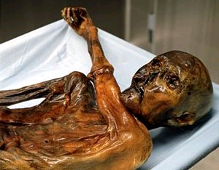  Ötzi the Iceman is a well-preserved natural mummy of a man from about 3300 BC found in 1991 in the Schnalstal glacier in the Ötztal Alps, near Hauslabjoch on the border between Austria and Italy. The nickname comes from Ötztal, the region in which he was discovered. He is Europe's oldest natural human mummy, and has offered an unprecedented view of Chalcolithic (Copper Age) Europeans.  At the time of his death, Ötzi was approximately 165 cm (5 ft. 5 in.) tall, weighed about 38 kg (84 lbs.), and was about 45 years of age. Because the body was covered in ice shortly after his death, it only partially deteriorated. He spent his childhood near the present village of Feldthurns (Velturno), north of Bolzano, but later went to live in valleys about 50 km further north.  Ötzi's clothes were quite sophisticated. He wore a cloak made of woven grass and a vest, a belt, a pair of leggings, a loincloth and shoes, all made of leather. He also wore a bearskin cap with a leather chin strap. The shoes were waterproof and wide, seemingly designed for walking across the snow; they were constructed using bearskin for the soles, deer hide for top panels, and a netting made of tree bark. Soft grass went around the foot and in the shoe and functioned like warm socks. The vest, belt, leggings, and loincloth were constructed of vertical strips of leather sewn together with sinew. His belt had a pouch sewn to it that contained a cache of useful items: a scraper, drill, flint flake, bone arrow, and a dried fungus to be used as tinder.  The shoes have since been reproduced by experts, and found to constitute such excellent footwear that there were plans for commercial production. Other items found with the Iceman were a copper axe with a yew handle, a flint knife with an ash handle, a quiver of 14 bone-tipped arrows with viburnum and dogwood shafts and flint heads (two arrows were finished, twelve were not), and an unfinished yew longbow that was 3 feet 2 inches (one metre) tall.  Among Ötzi's possessions were two species of polypore mushrooms with leather strings through them. One of these (the birch fungus) is known to have antibacterial properties, and was likely used for medicinal purposes. The other was a type of tinder fungus, included with part of what appeared to be a complex firestarting kit. The kit featured pieces of over a dozen different plants, in addition to flint and pyrite for creating sparks.  Otzi died from a head wound and was quickly buried in ice, preserved for 5,000 years.
Giza Pyramids | 2500 BC | The Great Pyramid of Giza is the oldest and largest of the three pyramids in the Giza Necropolis bordering what is now Cairo, Egypt in Africa, and is the only remaining member of the Seven Wonders of the World. It is believed to have been built as a tomb for Fourth dynasty Egyptian pharaoh Khufu and constructed over a 20 year period concluding around 2560 BC. It remained he tallest structure in the world for over 3,800 years, and puzzles many scientists today due to its craftsmanship and the logistics required to construct a structure of this magnitude within the allotted timeframe.  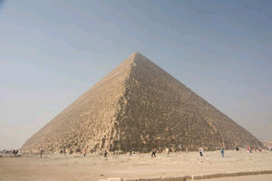  A variety of estimates and studies have been made regarding the time, manpower and logistics required to create the pyramids. Many time-motion studies and conclusions regarding its construction focus on the labor aspects of construction and do not take into consideration the location and source of materials, nor the precision of the construction. The pyramid is estimated to consist of over 2.4 million stones, each stone weighing anywhere from 1.5 to 80 tons. Although the bulk of the limestone construct came from quarries 20 miles away, some stones were transported from quarries as far away as 500 miles. Conservative estimates would require that the stone blocks were laid at a rate of one every 55 seconds.  The precision of the pyramid's workmanship is nothing short of astonishing. Each of the four sides (230.4m, or 755.8 ft long) of the 13-acre base have a mean error of only 58mm in length, and 1 minute in angle from a perfect square. The base is horizontal and flat to within 15mm. The sides of the square are closely aligned to the four cardinal compass points to within 3 minutes of arc and is based not on magnetic north, but true north. The design dimensions, as confirmed by Petrie's survey and all those following this, are assumed to have been 280 cubits in height by 4x440 cubits around originally, and as these proportions equate to 2 x Pi to an accuracy of better than 0.05%, this was and is considered to have been the deliberate design proportion. The pyramid was constructed of cut and dressed blocks of limestone, basalt and granite. The core was made mainly of rough blocks of low quality limestone taken from a quarry at the south of Khufu’s Great Pyramid. These blocks weighed from two to four tons on average, with the heaviest used at the base of the pyramid. High quality limestone was used for the outer casing, with some of the blocks weighing up to 15 tons. This limestone came from Tura, about 14 km away on the other side of the Nile. The granite chambers and hallways were quarried from nearly 800 km away in Aswan, with blocks weighing as much as 60-80 tons.  At completion, the Great Pyramid was surfaced by white 'casing stones' - slant-faced, but flat-topped, blocks of highly polished white limestone. These caused the monument to shine brightly in the sun, making it visible from a considerable distance. Visibly all that remains is the underlying step-pyramid core structure seen today, but several of the casing stones can still be found around the base. The casing stones of the Great Pyramid and Khafre's Pyramid (constructed directly beside it) were cut to such optical precision as to be off true plane over their entire surface area by only 0.5 mm. The stones were fitted together so perfectly that the tip of a knife cannot be inserted between the joints even to this day.  The passages inside the pyramid are all extremely straight and precise, such that the longest of them, referred to as the descending passage, which is 107 m long, deviates from being truly straight by less than 6 mm, while one of the shorter passages with a length of just over 15 m deviates from being truly straight by a mere 0.5 mm.  There are three known chambers inside the Great Pyramid. These are arranged centrally, on the vertical axis of the pyramid. The lowest chamber (the "unfinished chamber") is cut into the bedrock upon which the pyramid was built. This chamber is the largest of the three, but totally unfinished, only rough-cut into the rock. The middle chamber, or Queen's Chamber, is the smallest, measuring approximately 5.74 by 5.23 meters, and 4.57 meters in height. Its eastern wall has a large angular doorway or niche, and two narrow shafts, about 20 cm wide, extending from the chamber towards the outer surface of the pyramid. At the end of the lengthy series of entrance ways leading into the pyramid interior is the structure's main chamber, the King's Chamber. This chamber was originally 10 x 20 x 11.2 cubits, or about 5.25 m x 10.5 m x 6 m, comprising a double 10x10 cubit square, and a height equal to half the double square's diagonal.  Scholars estimate that the pyramids were emptied of their treasures sometime prior to 820AD.
Ur | 2500 BC | 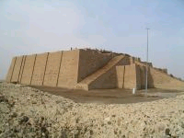  Ur was an ancient city in southern Mesopotamia, located near the mouth (at the time) of the Euphrates and Tigris rivers on the Persian Gulf and close to Eridu. It is considered to be one of the earliest known civilizations in world history. Because of marine regression, the remains are now well inland in present-day Iraq, south of the Euphrates on its right bank, and named Tell el-Mukayyar, near the city of Nasiriyah south of Baghdad. It is considered by some to be the same city that Abraham came from (Gen 12). Some consider Ur to be located to the north of Mesopotamia, near Huran.  The southern site is marked by the ruins of a ziggurat, still largely intact, and by a settlement mound. The ziggurat is a temple of Nanna, the moon deity in Sumerian mythology, and has two stages constructed from brick: in the lower stage the bricks are joined together with bitumen, in the upper stage they are joined with mortar. The Sumerian name for this city was Urim, and it dates to approximately 2500 BC.
Stonehenge | 2200 BC | 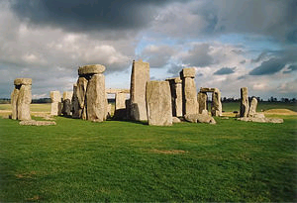  Stonehenge is a prehistoric monument located in the English county of Wiltshire, about 8 miles (13 km) north of Salisbury. One of the most famous prehistoric sites in the world, Stonehenge is composed of earthworks surrounding a circular setting of large standing stones. Archaeologists believe the standing stones were erected around 2200 BC and the surrounding circular earth bank and ditch, which constitute the earliest phase of the monument, have been dated to about 3100 BC. As a point of reference, Abraham was born in 2166 BC.  Stonehenge is a place of pilgrimage for neo-druids and those following pagan or neo-pagan beliefs. The midsummer sunrise began attracting modern visitors in the 1870s, with the first record of recreated Druidic practices dating to 1905 when the Ancient Order of Druids enacted a ceremony. Despite efforts by archaeologists and historians to stress the differences between the Iron Age Druidic religion and the much older monument, Stonehenge has become increasingly, almost inextricably, associated with British Druidism, Neo Paganism and New Age philosophy. After the Battle of the Beanfield in 1985 this use of the site was stopped for several years, and currently ritual use of Stonehenge is carefully controlled.
Hyksos | 1720 – 1564 BC | The Hyksos were an Asiatic people who invaded the eastern Nile Delta, initiating the Second Intermediate Period of Ancient Egypt. They rose to power in the 17th century BC, (according to the traditional chronology) and ruled Lower and Middle Egypt for 108 years, forming the Fifteenth and possibly the Sixteenth Dynasties of Egypt, (c. 1648-1540 BC). This 108-year period follows the Turin Canon, which gives the six kings of the Hyksos 15th Dynasty a total reign length of 108 years. Some scholars maintain that the Hyksos reign lasted 150 years.  Traditionally, only the six Fifteenth Dynasty rulers are called "Hyksos". The Hyksos had Canaanite names, as seen in those which contain the names of Semitic deities such as Anath or Ba'al. They introduced new tools of warfare into Egypt, most notably the composite bow and the horse-drawn chariot.  Some scholars, as early as Josephus, have associated the Semitic Hyksos with the ancient Hebrews, seeing their departure from Egypt as the story retold in the Exodus. The Biblical chronology does not align the Children of Israel with the dating of the Hyksos.  The rule of these kings overlaps with that of the native-Egyptian pharaohs of the 16th and 17th dynasties of Egypt, better known as the Second Intermediate Period. The first pharaoh of the 18th dynasty, Ahmose I, finally expelled the Hyksos from their last holdout at Sharuhen in Gaza by the 16th year of his reign.
Ahmose I | 1570 - 1564 BC | 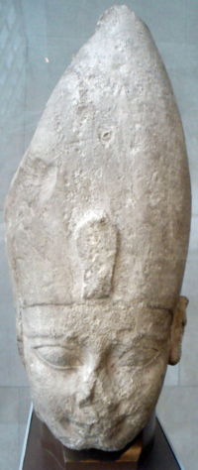  Ahmose I was a pharaoh of ancient Egypt and the founder of the Eighteenth dynasty. He was a member of the Theban royal house, the son of pharaoh Tao II Seqenenre and brother of the last pharaoh of the Seventeenth dynasty, King Kamose. Sometime during the reign of his father or grandfather, Thebes rebelled against the Hyksos, the rulers of Lower Egypt.  During his reign he completed the conquest and expulsion of the Hyksos from the delta region, restored Theban rule over the whole of Egypt and successfully reasserted Egyptian power in its formerly subject territories of Nubia and Canaan. He then reorganized the administration of the country, reopened quarries, mines and trade routes and began massive construction projects of a type that had not been undertaken since the time of the Middle Kingdom. This building program culminated in the construction of the last pyramid built by native Egyptian rulers. Ahmose's reign laid the foundations for the New Kingdom, under which Egyptian power reached its peak. His reign is usually dated to about 1570-1564 BC.
Eighteenth Dynasty | 1550 – 1292 BC | The Eighteenth Dynasty of Egypt (1550-1292 BC) is perhaps the best known of all the dynasties of ancient Egypt. It featured a number of Egypt's most powerful pharaohs, including Tutankhamun, whose undisturbed tomb, uncovered by Howard Carter in 1922, was one of the greatest of all archaeological discoveries. It is sometimes known as the Thutmosid Dynasty because all four of the Thutmosis pharaohs ruled during this period. Hatshepsut, and perhaps two others of a handful of native women known to be crowned king of Egypt, ruled during this dynasty, as did Akhenaten (also known as Amenophis IV), the "heretic Pharaoh" who with his wife, Nefertiti, instituted what may be the first monotheistic state religion.  This dynasty often is combined with the Nineteenth and Twentieth dynasties under the group title, New Kingdom.
Hatshepsut | 1504 – 1483 BC | 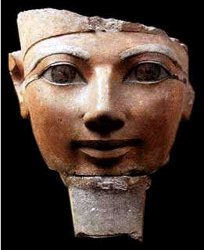  Hatshepsut, meaning “Foremost of Noble Ladies”, was the fifth pharaoh of the Eighteenth Dynasty of Ancient Egypt. She is generally regarded by Egyptologists as one of the most successful female pharaohs, reigning longer than any other woman of an indigenous Egyptian dynasty. Her reign is in dispute, but likely from about 1504 to 1483BC. Only a handful of other women were considered to be pharaohs, including Nefertiti, Meritaten, Neferneferuaten, and Twosret. The most famous was Cleopatra VII, a non-Egyptian and the last pharaoh of Ancient Egypt.  Some Biblical scholars believe there is credible support to assume she is the pharaoh's daughter that drew Moses from the Nile. The basis for this assumption has to do with the timing of the birth of Moses, the rule of Hatshepsut and other convincing similarities between Egyptian history and the Biblical account. There are more than a few students of Egyptian history that add more to her story.  Hatshepsut & Senmut (the following story is based largely on historical fact, with unconfirmed assumptions added. It is a popular opinion among many Muslim students of Egyptology.)  According to ancient Egyptian mythology, one of the first pharaohs to rule Egypt was Osiris. He married his ½ sister, Isis, and ruled over all of Egypt. As was the custom, his son would become pharaoh after his death. But in a fit of envy, his brother, Set, killed Osiris and tried to seize the throne. Isis was not about to let her ½ brother / brother-in-law rule, so she consulted with the temple priests and had them resurrect her husband long enough to impregnate her. Her son was named Horus and was declared to be Osiris reincarnated. This made Horus her son/husband/brother. Isis convinced her people that because the gods smiled favorably upon her, she, a female, should control Egypt and rule it while Horus was being prepared to assume rule of pharaoh. It worked, and she became Egypt’s first female pharaoh. Or so the legend goes.  Fast-forward to 1525BC. Thutmose I is the pharaoh and he has dilemma on his hands. He has two daughters and no sons. Royal succession of the pharaohs requires that the title be passed to the first-born son or the husband of the first-born daughter. Neither of his daughters are married, so he begins to search for a suitable husband for his ~15yr old daughter, Hatshepsut. He chooses another son of his, Hatshepsut’s ½ brother. But Hatshepsut had plans of her own. She didn’t particularly care for the idea of being married off, in fact, she had greater plans: She wanted to be pharaoh herself. But in order to pull that off, she needed the gods to smile favorably upon her.  One day while bathing at the Nile river, Hopi, the god of the Nile, decides to show a blessing on Hatshepsut by sending her a young boy in a basket through crocodile-infested waters. She draws the boy out of the water and names him Senmut, which means “mother-brother”. She convinces her father that, like Isis, the gods have shown her favor by sending her a son to raise to be pharaoh. In the meantime, her husband assumes the throne as Thutmose II, but lives a short and ineffective life and produced no offspring with Hatshepsut. But he does have a son through one of his concubines. After Thutmose II dies, Hatshepsut gains control not as queen, but as pharaoh. When Thutmose II’s illegitimate son becomes old enough, he becomes pharaoh of the northern ½ of Egypt under the title Thutmose III. Hatshepsut retains control of the southern ½ of Egypt, with Senmut at her side. She was Egypt’s first “real” female pharaoh, and was often depicted as a male (and, according to some Egyptologists, even dressed as a male). As we might expect, Thutmose III bitterly hated his step-mother and Senmut. (Many Egyptologists believe that Senmut s Hatshepsut’s lover, not adopted son. What’s not in dispute is that Senmut and Hatshepsut shared a very close and unusual relationship. The statue of Senmut holding Hatshepsut’s daughter has been interpreted by some to be Hatshepsut holding Senmut.)  While Hatshepsut strengthened Egypt’s might by new trade to foreign lands, Thutmose III was a mighty warrior, suppressing Egypt’s enemies and gaining new territory for Egypt. Senmut rose through the ranks very quickly and was the architect and builder of many of Hatshepsut’s projects, including her mortuary temple at Deir el-Bahri, just outside of Luxor.  Shortly before Hatshepsut’s death, Senmut suddenly disappeared. Egyptologists have no record of his disappearance, and the two burial tombs he built for himself were never used. After Hatshepsut’s death, Thutmose III vandalized her tomb, historical accounts, statues and sarcophagus. By defacing her works and removing her name from the chest of her sarcophagus, he believed he was preventing her soul from finding her body in order reincarnate her.  Statues of Senmut and Hatshepsut are on display in several museums around the world, including the Cairo Museum.
Thutmose III | 1490 – 1450 BC | 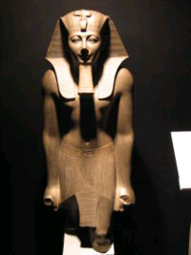  Thutmose III (sometimes read as Thutmosis or Tuthmosis III) was the sixth Pharaoh of the Eighteenth Dynasty. During the first 22 years of Thutmose's reign he was co-regent with his stepmother, Hatshepsut. While she is shown first on surviving monuments, both were assigned the usual royal names and insignia and neither is given any obvious seniority over the other. After her death and his subsequent gain of power over his kingdom, he created the largest empire Egypt had ever seen; no less than seventeen campaigns were conducted, and he conquered from Niy in north Syria to the fourth cataract of the Nile in Nubia. After his years of campaigning were over, he established himself as a great builder pharaoh as well. Thutmose III was responsible for building over fifty temples in Egypt and building massive additions to Egypt's chief temple at Karnak. New levels of artistic skills were reached during his reign, as well as unique architectural developments never seen before and never again after his reign. When he died he was buried in the Valley of the Kings like the rest of the kings from this period in Egypt, and was succeeded by his son Amenhotep II, with whom he had a short 2 year co regency. Thutmose III officially ruled Egypt for almost 54 years, and his reign is sometimes dated from April 24, 1479 to March 11, 1425 BC; however, the first 22 years of his reign was dominated by the presence of Hatshepsut--his step-mother and the senior king of Egypt.  Many Biblical scholars believe Thutmose III is the pharaoh of the oppression of the Children of Israel. (see Exodus)
Ipuwer Papyrus | 1450 BC | The Ipuwer Papyrus ("Dialogue of Ipuwer and the Lord of All") is an ancient Egyptian poem preserved on a single papyrus, Leiden Papyrus I 344, which is housed in the National Archeological Museum in Leiden, Netherlands. It dates to about 1450 BC, the same time as Moses' exodus from Egypt. Ipuwer describes Egypt as afflicted by natural disasters and in a state of chaos, a topsy-turvy world where the poor have become rich, and the rich poor, and warfare, famine and death are everywhere. Many scholars reject that idea that the Egyptian is describing the events of the Ten Plagues, while others see too many references for it to be a coincidence:  1. The Plague of Blood  Ipuwer Papyrus 2:5-6 - "Plague is throughout the land. Blood is everywhere."  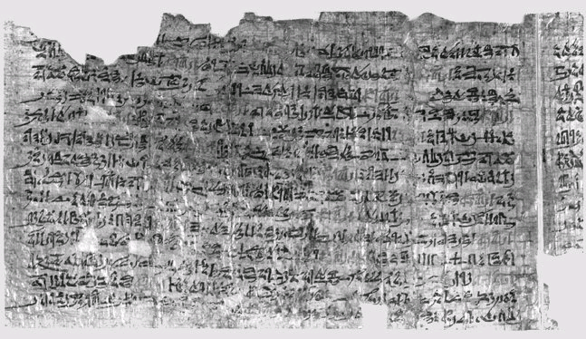  Ipuwer Papyrus 2:10 - "The River is Blood, men shrank from tasting, and thirst for water."  Exodus 7:21 - "There was blood throughout all the land of Egypt."  Exodus 7:20, 24 - All the waters that were in the river were turned to blood and wells had to be dug.  2. The Plague of Hail  Ipuwer papyrus 4 - "Indeed, trees are felled and branches are stripped off."  Ipuwer papyrus 9:23 - "The fire ran along the ground. There was hail, and fire mingled with the hail."  Exo 9:24 - "And there was hail, and fire flashing in the midst of the hail, very heavy, which never had been in all the land of Egypt since it became a nation."  3. The Plague of Darkness  Ipuwer Papyrus 9:11 - "The land is not light."  Exodus 10:22: "And there was a thick darkness in all the land of Egypt."  4. The Plague of Egyptian Cattle  Ipuwer papyrus 5:5 - "All animals, their hearts weep. Cattle moan."  Exodus 9:3 - "Behold, the hand of the Lord is upon thy cattle which is in the field, upon the horses, upon the asses, upon the camels, upon the oxen, and upon the sheep: there shall be grievous murrain (disease)."  5. The Plague of the Firstborn of Egypt  Ipuwer Papyrus 2:13 - "He who places his brother in the ground is everywhere."  Ipuwer Papyrus 4:3 - "Forsooth, the children of princes are dashed against the walls."  Ipuwer Papyrus 6:12 - "Forsooth, the children of the princes are cast out in the streets."  Exo 12:29 - "And it happened at midnight. Jehovah struck every first-born in the land of Egypt, from the first-born of Pharaoh, the one sitting on the throne, to the first-born of the captive who was in the prison house, and every first-born of animals."  6. Response of the Egyptians to the Loss of their First born  Ipuwer Papyrus 3:14 - "It is groaning that is throughout the land, mingled with lamentations."  Exodus 12:30 - "There was a great cry in Egypt."  And more…  - the tribes of the desert have become Egyptians everywhere.  - Indeed, poor men have become owners of wealth, and he who could not make sandals for himself is now a possessor of riches.  - barbarians from abroad have come to Egypt.  - Indeed, gold and lapis lazuli, silver and turquoise, carnelian and amethyst, Ibhet-stone and [. . .] are strung on the necks of maidservants.  - Indeed, every dead person is as a well-born man. Those who were Egyptians [have become] foreigners and are thrust aside.  - Indeed, the hot-tempered man says: "If I knew where God is, then I would serve Him."  - Behold, the possessors of robes are now in rags, while he who could not weave for himself is now a possessor of fine linen.  - Behold, the poor of the land have become rich, and the [erstwhile owner] of property is one who has nothing.  - Behold, a man is happy eating his food. Consume your goods in gladness and unhindered, for it is good for a man to eat his food; God commands it for him whom He has favored.
Amenhotep II | 1450 - 1419 | Amenhotep II (sometimes read as Amenophis II) was the seventh Pharaoh of the 18th dynasty of Egypt. Amenhotep inherited a vast kingdom from his father Thutmose III, and held it by means of a few military campaigns in Syria; however, he fought much less than his father, and his reign saw the effective cessation of hostilities between Egypt and Mitanni, the major kingdoms vying for power in Syria. His reign is usually dated from 1450 to 1419 BC.  Many Biblical scholars believe Amenhotep II is the pharaoh of the Exodus of the Children of Israel. History tells us that he had an older brother that died in infancy. This explains why he did not die when the Tenth Plague struck the firstborn of Egypt. (see Exodus)
Exodus | 1446 BC | The Exodus There have been a number of dates proposed for the Exodus. Of the two most popular dates, conservative Biblical scholars usually go with 1446 BC (also known as “the early date view”) for several reasons. A) The date for Solomon’s reign is widely accepted to have begun in 970 BC. B) 1 Kings 6:1 says that the construction of Solomon’s temple began in the fourth year of his reign, 480 years after the Exodus. This places the exodus at 1446 BC, and Joshua’s conquest of Canaan, after 40 years of wilderness wandering, at 1406 BC. This would mean that the pharaoh of the oppression would be Thutmose III and the pharaoh of the Exodus would be Amenhotep II.  Many scholars embrace the “late date view” of the Exodus by downplaying the accuracy of the 480 years mentioned in 1 Kings 6:1, ignoring Acts 13, and dismissing Judges 11. They suggest that the 480 years is a figurative number representing “a long time” of 40 years of trials multiplied by 12 tribes. There is some evidence that widespread destruction in Canaan did not take place in 1400 BC, but rather 1230 BC (which would place the Exodus in 1270 BC under Ramses the Great, as depicted in most movies about the Exodus).  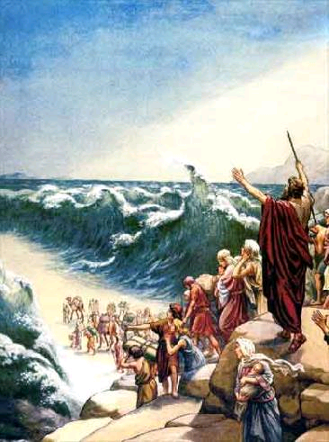  Conservative Biblical scholars counter this argument by pointing out that Joshua slated only 3 cities for destruction: Jericho, Ai and Hezor. The rest were ‘taken over’ and assimilated, and would therefore not leave huge signs of destruction. Additionally, Merneptah, the successor to Ramses, wrote in 1209 BC (60 years after the “late date” Exodus) about Israel, implying that it was an established nation. If the Exodus took place in 1270 BC, Israel could not have been an established nation for at least 40 years past the Exodus (due to the wilderness wanderings) plus at least another 60 years of conquest by Joshua and the Judges.  Regardless of the exact date of the Exodus, matching the pharaoh to the Biblical account is not very difficult. The narrative in the book of Exodus suggests that the pharaoh of the oppression ruled for approximately 40 years. From 1700 BC to 1000 BC, this stipulation only applies to two pharaohs: Thutmose III and Ramses II.  There are several other dates that have been proposed, but are minority views and lack solid archaeological or Biblical support:  - In a documentary called “Exodus Decoded”, director Simcha Jacobovici suggested, among other things, that Pharaoh Ahmose I was the pharaoh of the Exodus, the Hyksos and the Jews are one and the same, and that the Ten Plagues were triggered by the volcanic eruption of Mt. Santorini in about 1500 BC. This is a novel view, but ignores many hints and statements in the Bible and discards established timelines for the chronology of ancient Egypt.  - Siegmund Freud suggested that Moses and Pharaoh Akenaten were one and the same. He based this on Akenaten’s obsession with monotheism and the fact that Akenaten had a brother named Thut-moses. Embracing this view ignores both the Biblical account and Egyptian history in ways too numerous to list. It should be sufficient to note that Akenaten’s coffin is in Egypt, not some unknown hill or cave overlooking the Promised Land.  - Others have suggested that the 480 years listed in 1 Kings 6:1 should be 1,480 years. This would make the oppressed Hebrews the builders of the pyramids. This view does not enjoy scholarly support.
Ten Plagues | 1446 BC | The Ten Plagues (c. 1446 BC) It is quite plausible that God designed the ten plagues as deliberate affronts to the Egyptian religion.  Then the LORD said to Moses, "Go to Pharaoh, for I have hardened his heart and the hearts of his officials so that I may do these miraculous signs of Mine among them, and so that you may tell your son and grandson how severely I dealt with the Egyptians and performed miraculous signs among them, and you will know that I am the LORD." (Exo 10:1-2 HCSB)  - Nile turned to blood: Hapi, god of the Nile; Isis, goddess of the Nile; Khnum, guardian of the Nile  - Frogs: Heqet, goddess of birth (usually depicted with the head of a frog)  - Gnats: Set, the god of the desert  - Flies: Re, the sun god, his symbol may have been the fly  - Death of Livestock: Hathor, goddess with cow's head; Apis, the bull god, also a fertility symbol  - Boils: Sekhmet, had power over diseases; Sunu, god of pestilence; Isis, goddess of healing  - Hail: Nut, goddess of the sky; Osiris, god of crops and fertility; Set, god of storms  - Locusts: Nut, goddess of the sky; Osiris, god of crops and fertility  - Darkness: Re, the sun god; Horus, the sun god; Nut, goddess of the sky; Hathor, sky goddess  - Death of Firstborn: Min, god of reproduction; Hequet, goddess associated with childbirth; Isis, goddess protecting children; Egyptians believed that Pharaohs (and their first-born sons) were gods.
Akhenaten | 1353 – 1336 BC | 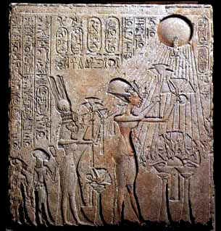  Akhenaten, first known as Amenhotep IV, was a Pharaoh of the Eighteenth dynasty of Egypt. An avid student of politics, art, history and religion, Akhenaten dropped the name Amenhotep IV and introduced the monotheistic religion of Atenism in the fourth year of his reign, raising the previously obscure god Aten to the position of supreme deity, and attacking the power of the Amen-Ra priestly establishment. Some speculate that his study of religion and history prompted him to imitate the One God of Moses, who brought Egypt and its polytheistic religion to its knees about 100 years prior (see Ten Plagues and Ipuwer Papyrus). Akhenaten was the first pharaoh to depict himself realistically (including his odd facial features, and saggy, unflattering body shape), depict his wife as being his equal, and depict himself and his wife in loving, playful relationships with their children. He was apparently reluctant to provide military support for the inhabitants of Palestine so they could fight off the “habiru”. (See the Amarna Tablets)  Akhenaten succeeded his father after Amenhotep III's death at the end of his 38-year reign, possibly after a coregency lasting between either 1 to 2 or 12 years. Suggested dates for Akhenaten's reign (subject to the debates surrounding Egyptian chronology) are from 1353-1336 BC or 1351-1334 BC. Akhenaten's chief wife was Nefertiti, made world-famous by the discovery of her exquisitely molded and painted bust, now displayed in the Altes Museum of Berlin, and among the most recognized works of art surviving from the ancient world.
Thutmose IV (sometimes read as Thutmosis or Tuthmosis I) was the 8th Pharaoh of the 18th dynasty of Egypt, and son of Amenhotep II. The length of his reign is not clear. He is usually given about nine or ten years of reign, though some historians give him a reign as long as 35 years (1419 to 1386 BC).

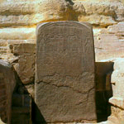
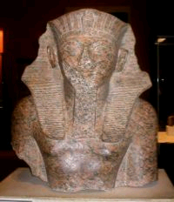
Dream Stele. Thutmose IV is best known for the Dream Stele, a stone engraving that sits between the paws of the Great Sphinx. In the Dream Stele, Thutmose IV describes a dream he had while napping in the shade of the head of the great sphinx. He dreamt that a god approached him and revealed to him the need to uncover the sphinx, and if he would do so, the god would make him king. In relaying this dream, Thutmose IV essentially confessed that he was not the heir-apparent to the throne. Some historians believe Thutmose IV killed his older brother in order to become king and later concocted the story of the dream in an effort to legitimize his kingship. Some Biblical scholars believe that Thutmose IV’s oldest brother was killed by the Angel of the Lord during the Tenth Plague.

Nuzi Tablets |  | Nuzi Tablets, discovered in 1935, are a collection of over 4,000 ancient Mesopotamian clay tablets written in Akkadian cuneiform. Located southwest of Kirkuk in modern Iraq, the tablets provided invaluable insights into the legal, commercial and military activities of the city. Although they date between 1500 BC to 1300 BC, they shed much light on the culture of the ancient Near East, including early versions of the stories of the characters Laban and Jacob found in the Book of Genesis.  The following examples may serve as illustrations of possible relationships between Nuzi and the Bible.  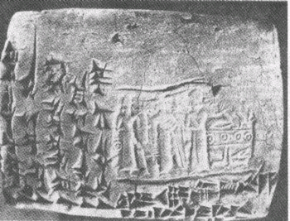  - In Nuzi a childless wife could give her handmaid to her husband so that the maid could bear children in the name of the wife. This practice was followed by Sarai, who gave her maid, Hagar, to her husband, Abram (Genesis 16:1-4). Rachel gave Bilhah to Jacob (Genesis 30:1-8). Leah gave Zilpah to Jacob (Genesis 30:9-13). In such a case, the father had a responsibility to rear the child as the offspring of his legal wife, and the wife could not drive away the child. According to this rule, Sarai had no right to drive out Hagar’s son, Ishmael (compare Genesis 16:4-6).  - In Nuzi there was a law against the sale of property outside one’s own family. Several schemes were used to get around this prohibition, including adoption and the exchange of property. In return for a guarantee of lifelong care and burial costs, a wealthy landowner would have himself "adopted" by landholding peasants so that he received their property. The records indicate that the very same man could be adopted by 300 or 400 peasants.  - A couple without children could legally adopt someone to provide for them in their old age and for their burial. The adopted person would be the heir to the property of his adopting parents. This may have been the relationship between Abram and his servant Eliezer (Genesis 15:2). One could also exchange property of little value for valuable property. In some instances, the difference in value could be made up in money. At Nuzi a man named Tehip-tilla sold his inheritance rights in a grove to his brother, Kurpazah, in exchange for three sheep. This parallels Esau’s sale of his birthright to Jacob for a serving of stew (Genesis 25:27-34).  - In Nuzi an oral will or blessing given on one’s deathbed was legally binding and could not be undone. A man named Huya was lying on his sickbed at the point of death. He took the hand of his son, Tarmiya, and gave to him a woman, Sululi-Ishtar, to be his wife. Tarmiya’s two brothers challenged his claim in court, but the court recognized the truth of Tarmiya’s case. Although Jacob obtained the blessing of his blind and aged father by deception, Isaac had to stand by what he had done (Genesis 27:33).  - The Nuzi tablets also indicate that the person who had possession of the teraphim, or household gods, was the heir to the property of the owner of the idols. For this reason, Rachel took the teraphim of her father Laban (Genesis 31:19), who was very disturbed over their disappearance (Genesis 31:30-35).  - Another case of adoption parallels the relationship between Jacob and Laban. Nashwi adopted Wullu and gave his daughter, Nuhuya, to him in marriage. If Wullu married another wife, he would have to forfeit the property he had received from Nashwi. Laban also made a covenant with Jacob that he would not take a wife other than Laban’s two daughters, Leah and Rachel (Genesis 31:50).
Tutankhamun |  | 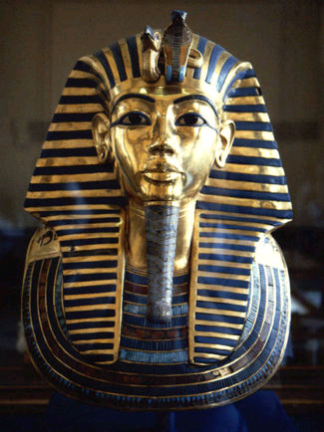  Nebkheperure Tutankhamun was a Pharaoh of the Eighteenth dynasty (ruled 1334 - 1325BC in the conventional chronology), during the period of Egyptian history known as the New Kingdom. His original name, given to him by his monotheistic father-in-law, Pharaoh Akhenaten, was Tutankhaten ("Living Image of Aten"). After his father-in-law's death, Tutankhamun (which means "Living Image of Amun") dropped the name Tutankaten, abolished the monotheistic religion of Atenism and converted Egypt back to polytheism. In order to prevent the return of his father-in-law's monotheistic religion, Tutankhamun destroyed many of Akhenaten’s images and removed Akhenaten’s name from his sarcophagus (Egyptians believed this would prevent the spirit from finding and re-entering the body). The "Boy King" died of gangrene at the age of 19 after a brief nine-year reign. His reign was relatively insignificant except for the fact that his small tomb (KV62 in the Valley of the Kings) was discovered in 1922 and was completely intact, full of spectacular wealth. His tomb received worldwide press and he is the only pharaoh to receive a nickname: King Tut. Nebkheperure Tutankhamun is possibly also the Nibhurrereya of the Amarna letters.
Amarna Tablets | 1480 – 1300 BC | Amarna Tablets An archive of several hundred correspondence tablets, mostly diplomatic, between the Egyptian administration and its subjects in Canaan and Amurru. The letters date between 1480 and 1300 BC and were primarily from the reign of Pharaoh Amenhotep IV, better known as Akhenaten. These tablets shed much light on Egyptian relations with Babylonia, Assyria, the Mitanni, the Hittites, Syria, Canaan, and Alashiya (Cyprus).  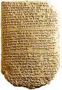  They are important for establishing both the history and chronology of the period. In many of the letters, kings of various Canaanite cities request money and military support in order to fend off the "Habiru", a group of people that were attacking various cities in the region. It is during this time that Joshua and the Children of Israel were taking the Promised Land for their own. Some speculate that Pharaoh Akhenaten was slow to respond to the plight of his subjects because he feared the God of the 'Habiru'. See Akhenaten.
Menmaatre Seti | 1290 – 1279 BC | Menmaatre Seti (better known as Seti I) was a Pharaoh of the Nineteenth dynasty of Egypt. He was the father of Ramses II (The Great). As with many dates in Ancient Egypt, various historians claim different dates for his reign, with 1290 - 1279 BC being the most commonly used by scholars today. Some scholars consider his son, Ramses The Great to be the pharaoh of the Exodus, so Seti I is depicted in several movies as the pharaoh of the Israelite oppression (Charlton Heston's "The Ten Commandments", etc.). There are a number of reasons to reject Ramses The Great as the pharaoh of the Exodus. (See Ramses II)  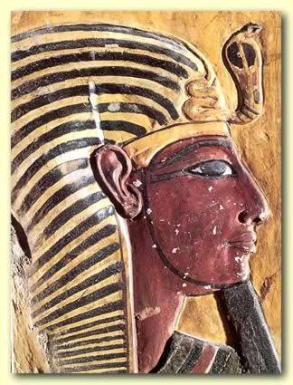  Seti was a military leader and conquered the north-east corner of the Egyptian Nile Delta along the northern coast of the Sinai peninsula ending in the town of Canaan in the modern Gaza strip. The traditional view of Seti’s wars was that he restored the Egyptian empire after it had been lost in the time of Akhenaten.  On his temple at Redesieh, Seti is represented holding some captives by the hair and threatening them with a club. These captives are named, amongst others, Shashu (Bedouins), Megiddoites, and Asuru, the last (it is generally agreed) being none else than the Hebrew tribe of Asher. This is the earliest mention of a Hebrew tribe by name outside the Bible.
Ramses II | 1279 – 1213 BC | Ramses II (also known as Ramses the Great) was the third Egyptian pharaoh of the Nineteenth dynasty. He is often regarded as Egypt's greatest and most powerful pharaoh. He was born as the second child to Seti I in approximately 1303 BC. At the age fourteen, Ramses was appointed Prince Regent by his father Seti I. He is believed to have taken the throne in his early 20s and to have ruled Egypt from 1279 BC to 1213 BC for a total of 66 years and 2 months, according to the Egyptian historian Manetho. Some historians believe that Ramses had as many as 8 wives and 40 - 100 children.  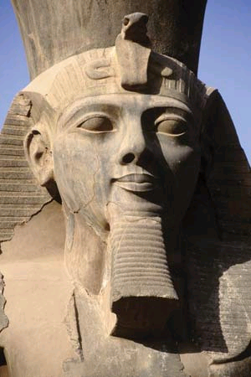  During his reign, Ramses built a vast array of temples, monuments and cities. Many of his monuments are well preserved, and still intact today. He established the city of Per- Ramses in the Nile Delta as his new capital and main base for the Hittite war. This city was built on the remains of the city of Avaris, the capital of the Hyksos during the 15th Dynasty. Ramses believed that this proximity to the Temple of Set enabled him to harness the power of Set, Horus, Re, Amun, and his father Seti. By some estimates, there are more statues of Ramses in existence than any other pharaohs, a testament to his strength and the length of his reign. Only one other pharaoh ruled longer than Ramses the Great: Pepi II in the sixth dynasty.  Movies often depict Ramses the Great as the pharaoh of the Exodus because many scholars believe the Exodus took place in 1270 BC. However Biblical chronology favors an Exodus of 1446 under the reign of Amenhotep II. (See Exodus)
Merneptah | 1213 – 1203 BC | Merneptah was the fourth ruler of the 19th Dynasty of Ancient Egypt. He ruled Egypt for almost 10 years between late July/early August 1213 to May 2 1203 BC according to contemporary historical records.[2] He was the thirteenth son of Ramses II[3] and only came to power because all his older brothers had predeceased him, by which time he was almost sixty years old.  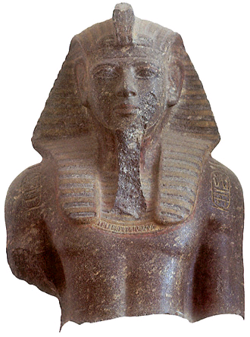  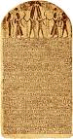  Merneptah is most famous for an account of his military against the Sea Peoples and Libu. This account is described in prose on a wall beside the sixth pylon at Karnak and in poetic form in the Merneptah Stele, widely known as the Israel Stele, which makes reference to the supposed utter destruction of Israel during campaign in his 6th year in Canaan: "Israel has been wiped out...its seed is no more." This is the first recognized ancient Egyptian record of the existence of Israel as a nation. Suffice it to say, he was wrong. Not only was Israel not wiped out, but they continue even to this day. The same cannot be said for Egyptian dynasties.
Shishak | 950 – 924 BC | 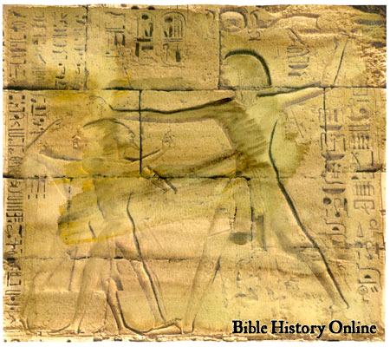  Shishak (also known as also known as Shoshenq I, Sheshonk or Sheshonq I) was a Meshwesh Libyan king of Egypt and founder of the Twenty-second Dynasty from approximately 950-924 BC. A majority of archaeologists and Egyptologists believe he is mentioned in the Bible as Shishaq (the first pharaoh mentioned by name in the Bible) though adherents of the so-called New Chronology have questioned this identification.  Shortly after Shishak the throne in 950 BC, Jeroboam the son of Nebat, of the tribe of Ephraim, whom Solomon had promoted but afterward had cause to suspect, fled from Solomon’s kingdom and took refuge in the court of Shishak (1 Kings 11:26). After the death of Solomon, Jeroboam returned to Canaan, and, on Rehoboam's returning an unsatisfactory answer to the people's demands for relief from their burdens, headed the revolt of the Ten Tribes, over whom he was chosen king with his capital at Shechem (1 Kings 12:25). Once Jeroboam became king of the northern Ten Tribes, Shishak attacked cities in the southern tribes and raided the temple in Jerusalem. His military campaign is listed both in 2 Chronicles 12:1-9 and on the temple of Karnak in Egypt. The details of the towns and districts conquered by Shishak are listed in detail at Karnak. This is the first Egyptian military campaign described in detail in both the Bible and in non-Biblical sources.
House of David Inscription | 950 BC | 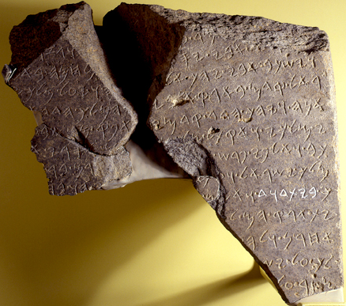  House of David Inscription (also referred to as the Tel Dan Stele) is a black basalt stele discovered during excavations at Tel Dan in northern Israel. It is a portion of a victory monument erected by an Aramaean king during the 9th century BC (250 years after David’s reign), and contains an Aramaic inscription commemorating victories over local ancient peoples including "Israel" and the "House of David." Its author is unknown, but may be a king of Damascus, Hazael or one of his sons.  It is the oldest extra-Biblical inscription referring to King David.
Gezer Calendar | 925 BC | 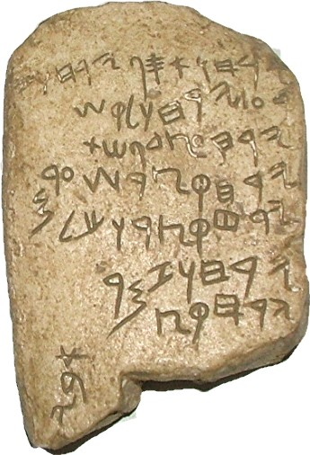  Gezer Calendar is a poetic recitation for the seasons of the year. It dates to about 950 BC (Solomon’s time), and was perhaps a way for children to memorize facts about the ancient Jewish calendar. This text is the earliest known example of Paleo-Hebrew writing found to date, and confirms that Hebrews had a written language prior to the Babylonian exile.  The inscription reads as follows:  His two months are (olive) harvest, His two months are planting (grain), His two months are late planting; His month is hoeing up flax, His month is harvest of barley, His month is harvest and feasting; His two months are wine - tending, His month is summer fruit.
Moabite Stone | 840 BC | Moabite Stone (also known as the Mesha Stele) is a black basalt stone, bearing an inscription by the 9th century BC Moabite King Mesha, discovered in 1868. The inscription of 34 lines, the most extensive inscription ever recovered from ancient Israel, was written in Paleo-Hebrew alphabet. The stele was installed by Mesha in about 850 BC as a record and memorial of his victories in his revolt against the Kingdom of Israel, which he undertook after the death of his overlord, King Ahab. (2 Kings 3:4)  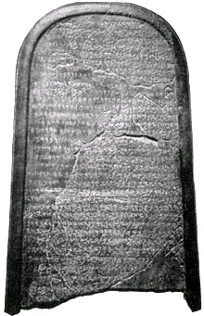  The stone is 124 cm (4 ft) high and 71 cm (2 ft 4 in) wide and deep, and rounded at the top. It was discovered at the ancient Dibon now Dhiban, Jordan, in August 1868, by Rev. F. A. Klein, a German missionary in Jerusalem. "The Arabs of the neighborhood, dreading the loss of such a talisman, broke the stone into pieces; but a squeeze had already been obtained by Charles Simon Clermont-Ganneau, and most of the fragments were recovered and pieced together by him".[1] A squeeze is a papier-mâché impression. The squeeze (which has never been published) and the reassembled stele (which has been published in many books and encyclopedias) are now in the Louvre Museum.
Shalmaneser Obleisk | 825 BC | The Neo-Assyrian bas relief obleisk of Shalmaneser III (858-842 BC) is the most complete Assyrian obleisk found to date. It stands at 6 ½ feet tall and features 20 reliefs – 5 on each of the 4 sides. The releifs depict five different subdued kings bringing tribute to Shalmaneser III. One of the kings is the Hebrew king Jehu, son of Omri. This releif is the earliest known depiction of an Israelite.  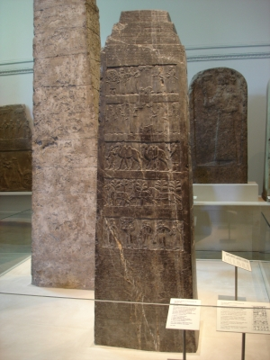  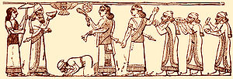  The caption above the scene, written in Assyrian cuneiform, can be translated as "The tribute of Jehu, son of Omri: I received from him silver, gold, a golden bowl, a golden vase with pointed bottom, golden tumblers, golden buckets, tin, a staff for a king [and] spears."  The obleisk is currently on display in the British Museum, and a copy is displayed at the Oriental Institute in Chicago, Illinois.
Yahweh Ostracon | 800 BC | An ostracacon (ostraca, in plural) is a piece of pottery that has been used to write a brief note or message.  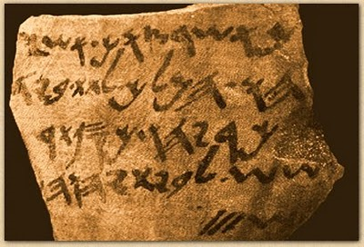  The Yahweh Ostracon measures approximately 3.5" high and 4.25" wide. The inscription is the earliest artificat referring to what is likely King Solomon's temple. It reads "According to your order, Ashya-hu the king, to give by the hand of [Z]ekaryahu silver of Tar-shish for the house of Yahweh 3 shekels"
Deir Alla Inscription | 800 Bc | Discovered in 1967 in an earthquake stricken structure, the Deir Alla Inscription recounts a prophet named Balaam, son of Beor – the same name of the pagan prophet that was paid to curse the Children of Israel in Numbers 23 (approx 1420 BC).  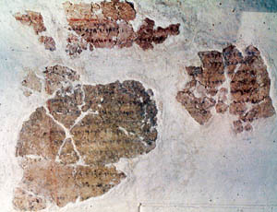  In this inscription, Balaam receives a vision from the god El, fortelling the doom of Shagar and Ishtar at the hands of the shaddayin. Balaam then uses a magical incantation to rescue Shagar and Ishtar from the shaddayin. There is also a reference to an underworld created by El named ‘sheol’.
Siloam Inscription | 701 BC | The Siloam inscription is a passage of inscribed text found in the Hezekiah tunnel (which feeds water from the Gihon Spring to the Pool of Siloam in East Jerusalem). The inscription records the construction of the tunnel in the 700 BC. It is among the oldest extant records of its kind written in Hebrew using the Paleo-Hebrew alphabet.  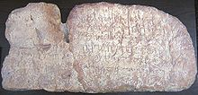  After its discovery in 1891, it was cut from the tunnel and broken into fragments. The pieces were eventually collected by the British Consul in Jerusalem, and the inscription is now on display at the Istanbul Archaeology Museum.
Taylor Prism | 689 BC | Discovered by Colonel Taylor in 1830 in Nineveh (northern Iraq), this clay prism records, in Akkadian, the annals of the Assyrian King Sennacherib.  Of special interest is his 701BC attack on Jerusalem and King Hezekiah. This event is recorded in several books of the Bible: Isaiah 33 & 36, 2 Kings 18 and 2 Chronicles 32. This event is also recorded by Herodotus. Although the prism does not agree with all the details laid out in the Bible, it does claim that Sennacherib had King Hezekiah shut up in Jerusalem “like a caged bird”.  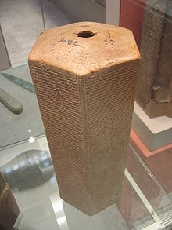
Ishtar’s Gate | 630 BC | South of modern-day Baghdad, in the ancient city of Babylon, is a recreation the Ishtar Gate - the Door of Babylon. The original gate was created by Nebuchadnezzar around 600 BC, and remains one of the most impressive monuments discovered in the ancient near East . It was one of 8 gates in the city wall. The 30’ wide Isthar Gate, so named after the Babylonian god Ishtar, was decorated with blue enameled bricks and gold relief images of dragons and bulls. The double-gate was the starting point for the half mile Processional Way to the Temple of Marduk. It is likely that Israelite slaves, including Daniel and Ezekiel, walked through this gate.  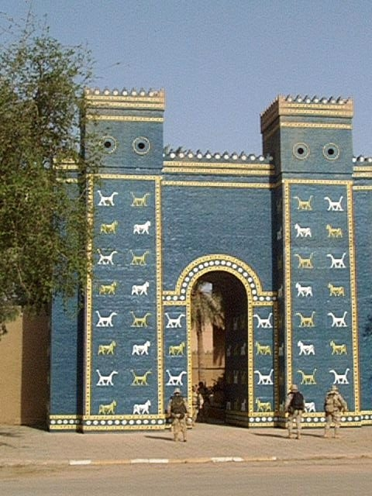
Cyrus Cylinder | 539 BC | 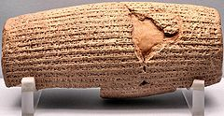  The Cyrus cylinder is a document issued by the Persian ruler Cyrus the Great in the form of a clay cylinder inscribed in Akkadian cuneiform script. When the Persian king ended the Babylonian empire by overthrowing King Nabonidus in 539 BC, he denounced Nabonidus and claims his actions were blessed by the Babylonian god Marduk. The cylinder states that Cyrus improved the lives of the Babylonians and sent exiled citizens back to their home lands to rebuild their temples.  The portion of the decree sending the Israelites is recorded in Ezra 1.
Elephantine Papyri | 450 BC | 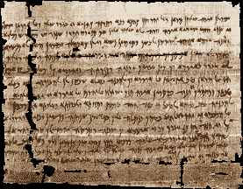  The Elephantine Papyri are a collection of ancient Jewish manuscripts dating from the fifth century BC. Written by a Jewish community at Elephantine, Egypt, the documents contain the ‘Passover letter’, a detailed set of instructions for properly keeping Passover. The arid soil of the Upper Egypt region helped preserve the hundreds of documents kept in this border fortress near Aswan.  The writing is hieratic and Demotic Egyptian, Aramaic, Greek, Latin and Coptic, and span a period of almost 1,000 years. Among the papyri are legal contracts, divorce documents, business communication, letters and other archives. They document the life and community of Jews among the solders stationed at Elephantine under Persian rule from 495 to 399 BC.
Septuagint | 250 BC
Dead Sea Scrolls | 150 BC

